Evaporative Condenser Pre-cooling

Test Protocol Development for Evaporative Pre-cooling of Residential HVAC condensers

**Prepared by:**

Mark Modera, Theresa Pistochini, Kevin Brown

Western Cooling Efficiency Center



**Prepared for:**

Customer Innovations

San Diego Gas and Electric

**Date:**

December 2, 2011

Table of Contents

Executive Summary 3

1 Background 4

2 Methods 4

Condenser performance and efficiency 5

Condenser Coil Differential Pressure 7

Water-Use Efficiency 7

3 Results 8

Model of condenser performance and efficiency 8

Wind Effects 15

Condenser Coil Differential Pressure 17

Water-Use 18

Economics 20

Installation and Operation 22

Evaporative Pre-Cooler Test Protocol 23

Discussion 25

# Executive Summary

The objective of this project is to develop and test a protocol for measuring the performance attributes of precooling technologies. These attributes include evaporative effectiveness, water consumption, efficiency improvement, the impact of wind and visual damage from the water.

WCEC tested the performance of one pre-cooler that is currently commercially available (Mist Ecology’s “AC Spritzer”), as installed on a high-flow Trane 3-ton condensing unit, model X-16i (). The condensing unit was located on the roof of the WCEC laboratory. The air conditioning system served the WCEC conference room.

The air conditioning system was monitored to measure the differential pressure across the condenser coil, the coefficient of performance of the system with and without the pre-cooler (using refrigerant side measurements), the evaporative effectiveness of the pre-cooler and pre-cooler water-use. Outdoor weather conditions were also monitored, including air temperature, relative humidity, and wind speed.

The pre-cooler was found to have an evaporative effectiveness of 51%. A model was developed to relate outdoor weather conditions to the expected condensing unit performance with the pre-cooler installed. The model was applied to simulated loads for a residential home generated using Miropas® for climate zones 2,9,10,11,12, and 13. The payback was as low as two years in climate zone 13. In climate zone 2, the payback time exceeded the life of the product.

The analysis of the data with respect to wind indicated some correlation, but it is difficult to discern, because there can be a time delay between changes in wind speed, and changes in performance, such that the performance change may happen minutes after the wind disruption. Further study is needed in this area.

The water-use of the pre-cooler averaged 0.51 liters per minute (0.135 gal/min)and the flow rate was fixed. However, not all water supplied to the pre-cooler is ultimately used for cooling. Water may be lost as run-off, through leaks, or in sprayed droplets that do not enter, or somehow do not serve to cool the condenser coil air stream. Over the course of the experiment, an average of 66% of the water was actually used for pre-cooling, and the amount was strongly correlated to outdoor air temperature and wet bulb depression.

The “AC Spritzer” was simple to install and held up well over the course of the experiment and protected the condenser coil from water droplets. The fiber glass “blanket” that caught the water drops had deteriorated by the end of the summer. This item should be replaced every 60-90 days according to the manufacturer.

Based upon the work performed, a draft testing protocol is proposed. Further development, testing and refinement of the protocol, particularly as applied to Roof-Top Units (RTUs), is being funded by the Southern California Edison HTSDA program, which is also helping to fund the construction of a test facility at the WCEC to perform such tests on smaller (i.e. <5-ton capacity) equipment.

# 1 Background

Engineering analyses suggest that significant energy and peak-demand savings (20-40%) can be realized by evaporatively cooling the intake air to condensing units in dry climates such as California. However, there are several impediments to more widespread adoption of this technology in California, the predominant impediment being uncertainty about the performance and longevity of the various products that have been appearing on the market. The issues include:

1. estimating the savings and performance improvements in different climate zones,
2. calculating the on-site water consumption required to achieve those results, and
3. quantifying the potential for increasing equipment maintenance needs.

The objective of this project was to address the impediments to the adoption of evaporative pre-cooling by developing and testing a protocol for measuring the performance attributes of these technologies by measuring the evaporative effectiveness of the cooling process, the water consumption required to achieve that effectiveness, the efficiency improvement produced by the cooling, and the impact of wind on the performance of the pre-cooler, as well as visually quantifying the impact of poor (i.e. Davis, CA) water quality on the condenser coil.

# 2 Methods

WCEC tested the performance of one pre-cooler that is currently commercially available (Mist Ecology’s “AC Spritzer”), as installed on a high-flow Trane 3-ton condensing unit, model X-16i (). The condensing unit was located on the roof of the WCEC laboratory. The air conditioning system served the WCEC conference room and was controlled locally from a thermostat that maintained the room temperature between 70-78ºF (21.1 °C to 25.6°C). As the water pressure in the City of Davis is low and highly variable, the water pressure was boosted to maintain a constant 60±2 (410 ±14 kPA) psig to the pre-cooler using a variable-speed pump. The condensing unit’s lid was removed to facilitate measurement of airflow for the experiment (it was not required for installation of the pre-cooler). The modification was left in place for both baseline tests and tests with the pre-cooler installed so that any small change in fan operation efficiency exists in both cases. The area of the exit for the airflow is similar for both the lid and for the modification. Figure 1 shows the condenser before and after modification and installation of the AC Spritzer.

The air conditioning system was monitored to measure the differential pressure across the condenser coil, the coefficient of performance of the system with and without the pre-cooler (using refrigerant side measurements), the evaporative effectiveness of the pre-cooler and pre-cooler water-use. Outdoor weather conditions were also monitored, including air temperature, relative humidity, and wind speed (). National Instruments hardware was used for data acquisition, LabVIEW was used for data logging, and Excel was used for post processing data. Data was sampled at 1Hz, averaged over 1 minute intervals, and logged to a text file. NIST’s RefProp software was used for calculating refrigerant enthalpies.

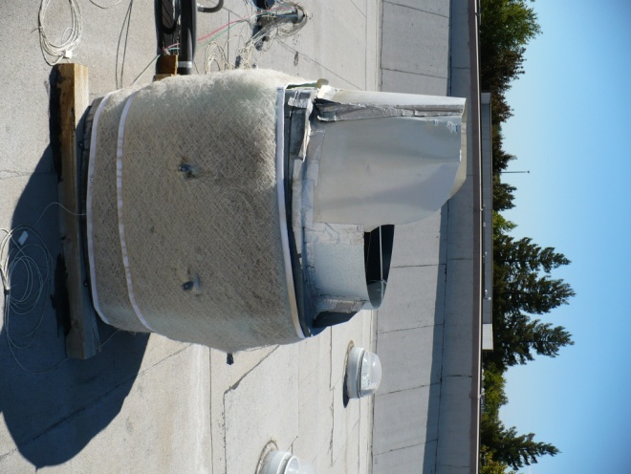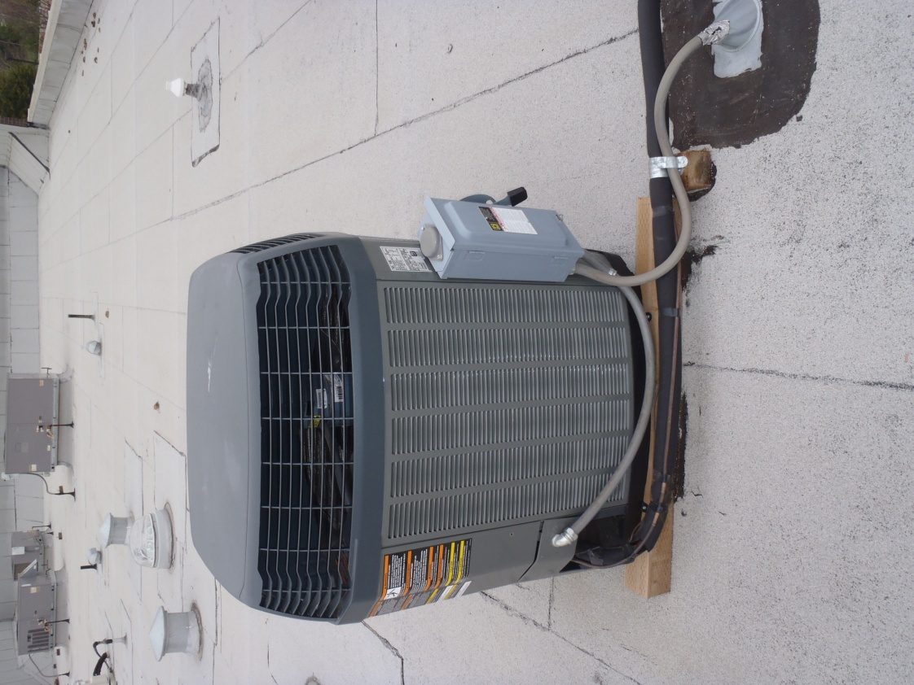

Figure 1- Trane X16i Condensing unit (left) with AC Spritzer installed (right)

Table 1 - Table of Instruments and Data Acquisition Equipment

|  |  |  |  |  |
| --- | --- | --- | --- | --- |
| **Measurement** | **Manufacturer/**  **Model #** | **Typical Value** | **Accuracy** | **DAQ** |
| Pressure Differential Across Condenser Coil | Energy Conservatory APT | 20 Pa | .1Pa | Serial |
| Weather Station (Temperature, Barometric Pressure, Relative Humidity, Wind Speed) | Vaisala | 30ºC 28% RH 2.5 m/s | ±.35ºC  3% RH  0.3 m/s | Serial |
| Condenser Air Exit Temperature and Humidity | Vaisala HMD60Y | 36ºC  33% RH | +/- 0.5ºC  2% RH | NI cDAQ  NI 9203 |
| Refrigerant Temperature (3 locations) | Omega PR-20 | 18-33ºC | Class A <0.2ºC | NI cDAQ  NI 9217 |
| Refrigerant Pressure  (Suction and Liquid) | ClimaCheck 200 105 | 0.9, 2.2 MPa | 0.035 MPa | NI cDAQ  NI 9203 |
| Power consumption Compressor | Watt Node  WNB-3D-240-P | 2.4kW | .5% of reading | NI PCIe-6320 |
| Power consumption Fan | WattNode  WNB-3D-240-P | 156W | .5% of reading | NI PCIe-6320 |
| Water Pressure | OmegaDyne PX209-100AI | 500KPa  absolute | .25% ~1.25kPa | NI cDAQ NI 9203 |
| Water Flow Rate | Omega - FTB601 | 9 ml/s | 3%  ~.27ml/s | NI PCIe-6320 |
| Water pH | CDTX-300 Transmitter | 8 | 0.5% fs 0.07 pH | NI cDAQ  NI 9203 |
| Water Conductivity | CDTX-300 Transmitter | 600 mS/cm | 2% fs .2 mS/cm | NI cDAQ  NI 9203 |
| Blower Door | Energy Conservatory | 3500 CFM | 3% of reading | Manual |

## 

# 3 Condensing Unit Performance and Efficiency

The power, capacity, and coefficient of performance (COP) of the condensing unit was measured before and after pre-cooler installation. The COP was measured using refrigerant side measurements. This was completed by calculating the specific enthalpy of the refrigerant before and after the compressor and before the expansion valve using measured temperatures and pressures (). The small refrigerant pressure drops across the condenser and evaporator were neglected.



**Figure 2 - Measurement points for refrigeration cycle. P and T represent locations of pressure and temperature transducers.**

From the enthalpies calculated before and after the compressor, as well as before the expansion valve, the COP is calculated from Equation :

|  |  |
| --- | --- |
|  | 1 |

where $∆h_{evaporator}$ is the specific enthalpy change across the evaporator, $∆h_{compressor}$ is the specific enthalpy change across the compressor, and $n_{t}$ is the thermal efficiency of the compressor, which is assumed to be 0.95. Note that this calculation does not include energy consumed by the air handler.

The mass flow rate of the refrigerant is needed to calculate the capacity. This can be found from Equation :

|  |  |
| --- | --- |
|  | 2 |

where $P_{comp}$ is the power to the compressor, $n_{t}$ is the thermal efficiency of the compressor and is estimated to be 0.95[1], and is the specific enthalpy change of the refrigerant across the compressor which is found by measuring the pressure and temperature change of the refrigerant. The capacity of the system is then found from Equation 3:

|  |  |
| --- | --- |
| $$Capacity={\dot{m}}_{ref}×{∆h}_{evaporator}$$ | 3 |

## Condenser Coil Differential Pressure

The pressure across the condenser coil was measured before and after installation of the pre-cooler. The differential pressure was also monitored during the course of the experiment to document any changes during operation. Scale buildup due to hard water use by the pre-cooler operation was a significant concern.

## Water-Use Efficiency

The amount of water use by the pre-cooler was measured continuously throughout the experiment. However, not all water supplied to the pre-cooler is ultimately used for cooling. Water may be lost as run-off, through leaks, or in sprayed droplets that do not enter, or somehow do not serve to cool the condenser air stream. Wind on rooftops generally will result in more wasted water by either blowing away water droplets or air that has been cooled by evaporation. The rate at which water is evaporated is:

|  |  |
| --- | --- |
| $${\dot{m}}_{water, evap}={(HR}_{outlet}-{HR}_{inlet})×{\dot{m}}_{air}$$ | 4 |

where ${HR}_{outlet}$ and ${HR}_{inlet}$ are the humidity ratio of the air exiting and entering the evaporative pre-cooler and ${\dot{m}}_{air}$ is the mass flow rate of air moving through the condensing unit. The humidity ratio of the entering air is calculated from the measured dry bulb and relative humidity. The humidity ratio of the exiting air is calculated from the known conditions of the entering air and the evaporative effectiveness of the pre-cooler. Measurement of the exiting air temperature and humidity was attempted but the measurement was easily disturbed by wind and found to be unreliable.

The mass flow rate of air through the condensing unit is extremely difficult to measure, given the inaccuracy of available air flow measurement devices, particularly for measuring the flow out of a condensing unit where the air exits the hood on all sides. Thus, the condensing unit exit was reconfigured to have a single round exit, and the air flow through that exit was measured by using a calibrated blower-door fan in series with the condenser fan. The blower-door fan setting was manipulated such that the condenser fan saw the same condition as it would if the blower-door fan was not there (i.e. free air). The water use effectiveness is then:

|  |  |
| --- | --- |
| $$w_{eff}={\dot{m}}_{water, evap}/{\dot{m}}_{water, supplied}$$ | 5 |

where ${\dot{m}}_{water, evap}$ is the rate at which water is evaporated from Equation , and is the water supplied to the evaporative pre-cooler (measured by the water meter).

# 3 Results

A model was developed to correlate pre-cooler performance, including its effect on the condensing unit power, capacity, and efficiency, with outdoor air temperature and humidity. These results were used to model the performance of the product in several California climate zones. Additionally, the effects of wind on performance were considered, although the data obtained were not robust enough to include in the model developed. Lastly, the water use of the product and the differential pressure across the condensing unit inlet grille with and without the pre-cooler installed were evaluated.

## Model of condensing unit performance and efficiency

The system has three measures of performance that vary with operating conditions. They are:

1. Power (fan + compressor)
2. Capacity
3. COP* (not including air handler)

These parameters were monitored over several days for three conditions: baseline, pre-cooler installed with water off (dry), and pre-cooler installed with water on (wet). The data was analyzed to develop a model that describes the performance of the pre-cooler as a function of the entering air dry bulb temperature and wet bulb temperature.

The performance data for the baseline unit, dry pre-cooler, and wet pre-cooler are plotted with respect to outdoor air temperature in Celsius, TDB, and a linear trend line was calculated (see Figures 3-5). Linear regressions were generated for the baseline and dry pre-cooler data (). The wet pre-cooler data is somewhat correlated to dry bulb data in the climate zone studied, but model with two variables (dry bulb and wet bulb temperatures) is required for a true representation of pre-cooler performance.

Table 2 – Linear fits of performance data for baseline, dry pre-cooler, and wet pre-cooler. TDB is the outside air dry bulb temperature in degrees Celsius.

|  |  |  |
| --- | --- | --- |
|  | Baseline | Dry Pre-cooler |
| Power (kW) | 61.80(TDB) + 770 | 69.24(TDB) + 590 |
| Capacity (kW) | -81.37(TDB) + 13,502 | -95.09(TDB) + 13,837 |
| COP | -0.15(TDB) + 8.95 | -0.13(TDB) + 8.37 |

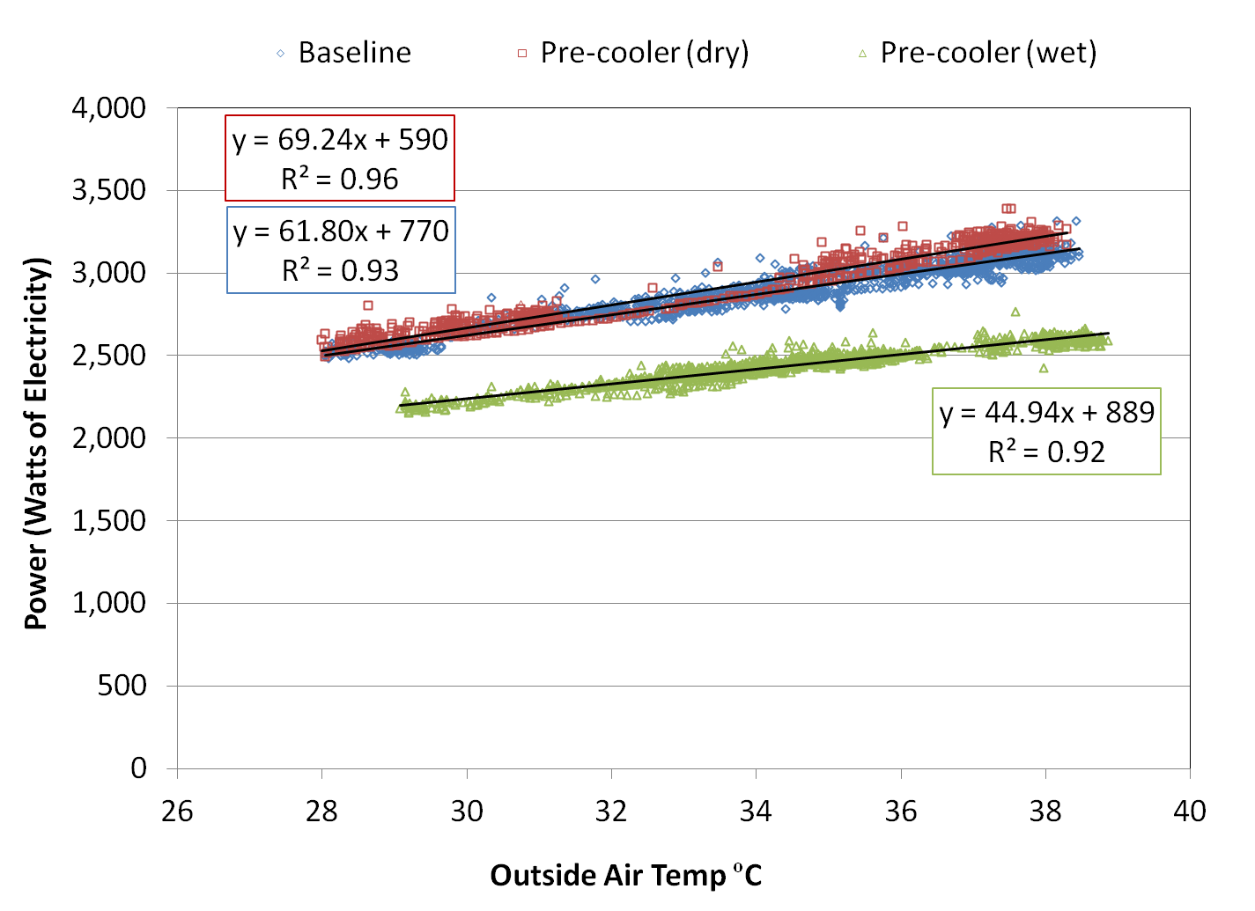

Figure 3 - System power for baseline, pre-cooler (dry), and pre-cooler (wet) with respect to outdoor air temperature

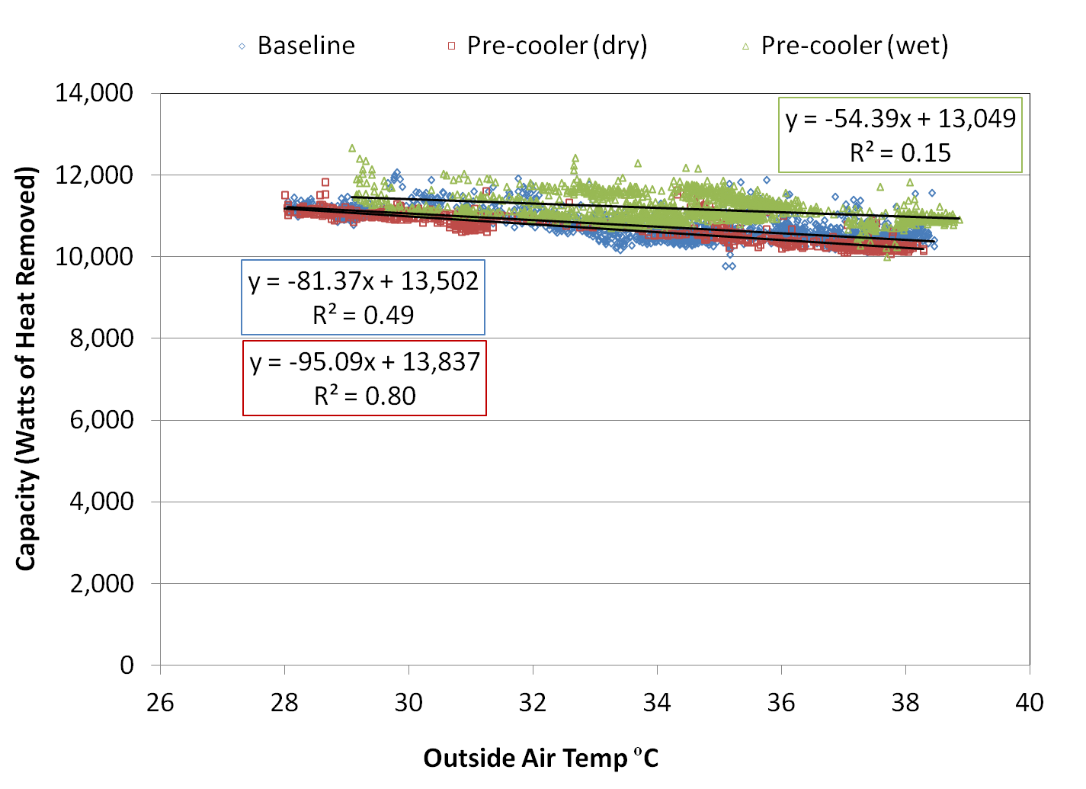

Figure 4 - System capacity for baseline, pre-cooler (dry), and pre-cooler (wet) with respect to outdoor air temperature

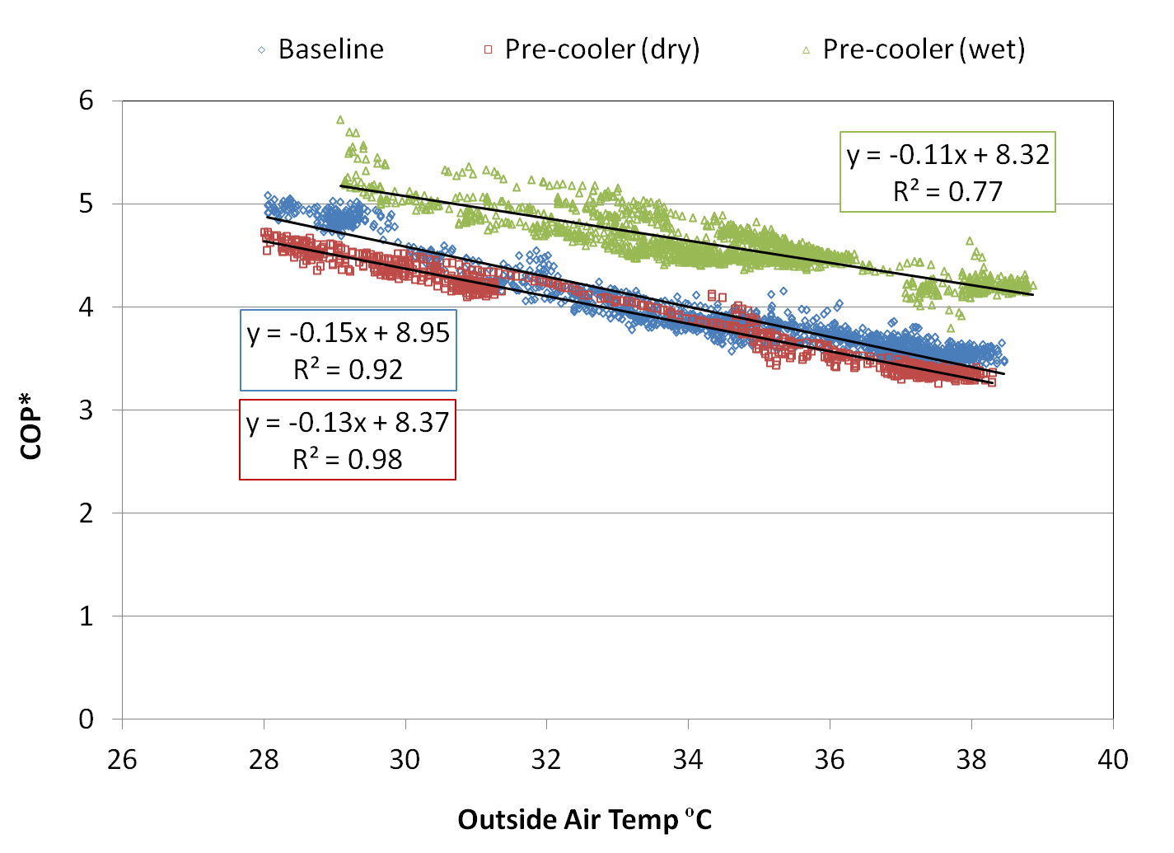

Figure 5 - System COP* for baseline, pre-cooler (dry), and pre-cooler (wet) with respect to outdoor air temperature. Power from indoor air handler is not included.

As seen in Figures 3-5, the performance of the baseline system is strongly correlated to outdoor air dry bulb temperature. Additionally, the performance of the baseline system with and without a dry pre-cooler installed are similar, meaning that the dry pre-cooler itself did not add significant resistance to the system, at least when it was first installed.

Figure 5 shows that the performance of the pre-cooler also correlates to outdoor air temperature and that the performance improvement associated with the pre-cooler is larger at higher ambient temperatures, however there are other factors impacting that performance improvement. The most important factor is wet bulb depression, the difference between the outdoor-air dry-bulb and wet-bulb temperatures, which determines how much pre-cooling can be achieved. A second factor is wind, which will be discussed later.

The pre-cooler improves system performance by dropping the temperature of the outside air entering the condensing unit in the direction of the wet-bulb temperature of that air. The ability of the pre-cooler to do this is its evaporative effectiveness (EE), defined as:

|  |  |
| --- | --- |
| $EE=\frac{T_{DB, in}-T_{DB, out}}{T_{DB, in}-T_{WB, in}}$ | 6 |

where $T_{DB, in}$ is the dry bulb temperature of the air entering the pre-cooler in ºC, $T_{DB, out}$ is the temperature of the air exiting the pre-cooler in ºC, and $T_{WB, in}$ is the wet bulb temperature of the air entering the pre-cooler in ºC. However, it is extremely difficult to measure the evaporative effectiveness of the pre-cooler in practice, because the presence of water complicates the performance of the instrumentation, and because the air exiting the pre-cooler is generally not well mixed. In addition, only pre-cooled air that actually enters the condensing unit provides an efficiency benefit to the refrigeration cycle. On the other hand, the measured condensing unit performance with the pre-cooler installed can be used to solve for its evaporative effectiveness.

A linear performance model was developed based on the evaporative effectiveness of the pre-cooler. The performance of the pre-cooler is modeled as:

|  |  |
| --- | --- |
| $$Perf={Perf}_{0}+\frac{{dPerf}_{dry}}{dT}(T_{DB}-T_{ref}-EE*WBD)$$ | 7 |

where Perf0 is the performance of the condensing unit at the reference temperature, $T_{ref}$ with a dry pre-cooler installed, $\frac{{dPerf}_{dry}}{dT}$ is the rate of change of condensing unit performance (with a dry pre-cooler) with respect to the outside-air dry bulb temperature ( $T_{DB})$ in ºC, WBD is the outside wet bulb depression in ºC, and EE is the evaporative effectiveness.

Equation was calculated for 1500 data points (containing one minute of data each) collected over four calendar days. Then, a single evaporative effectiveness was selected that resulted in the least root mean squared error (RMSE) between the actual and predicted performance data (). The coefficient of variation (CV), or the root mean squared error divided by the average value, is also shown.

The evaporative effectiveness required to minimize the error between the data and the model varied between 0.44-0.51 for the three performance metrics analyzed. The evaporative effectiveness was selected as 0.51 for the pre-cooler because the model developed using the power data had the lowest coefficient of variation (1.8%). The results calculated from the model with EE=0.51 are plotted against the actual data in Figures 6-8.

Lastly, the model was used to predict results for a second set of 458 data points not used in the model development. The model predictions are plotted against actual results in Figures 9-11. The validation shows good agreement with a coefficient of variation between 1.8%-2.9%.

Table 3 – Evaporative effectiveness calculated from performance measurements resulting in smallest RMSE

|  |  |  |  |  |
| --- | --- | --- | --- | --- |
| **Performance Metric** | **EE** | **RMSE** | **Average** | **CV** |
| Power | 0.51 | 44.0 Watts | 2442.4 Watts | 1.8% |
| Capacity | 0.46 | 323 Watts | 11,170 Watts | 2.9% |
| COP* | 0.44 | 0.18 | 4.6 | 3.9% |

Table 4 – RMSE calculated from performance measurements with EE = 0.51

|  |  |  |  |  |
| --- | --- | --- | --- | --- |
| **Performance Metric** | **EE** | **RMSE** | **Average** | **CV** |
| Power | 0.51 | 44.0 Watts | 2442.4 | 1.8% |
| Capacity | 0.51 | 331 Watts | 11,170 | 3.0% |
| COP* | 0.51 | 0.23 | 4.6 | 5.0% |

Table 5 – RMSE calculated from performance measurements with EE = 0.51 for subsequent data set that was not used in the model development

|  |  |  |  |  |
| --- | --- | --- | --- | --- |
| **Performance Metric** | **EE** | **RMSE** | **Average** | **CV** |
| Power | 0.51 | 67.1 Watts | 2396.3 | 2.8% |
| Capacity | 0.51 | 200 Watts | 11,357 | 1.8% |
| COP* | 0.51 | 0.14 | 4.9 | 2.9% |

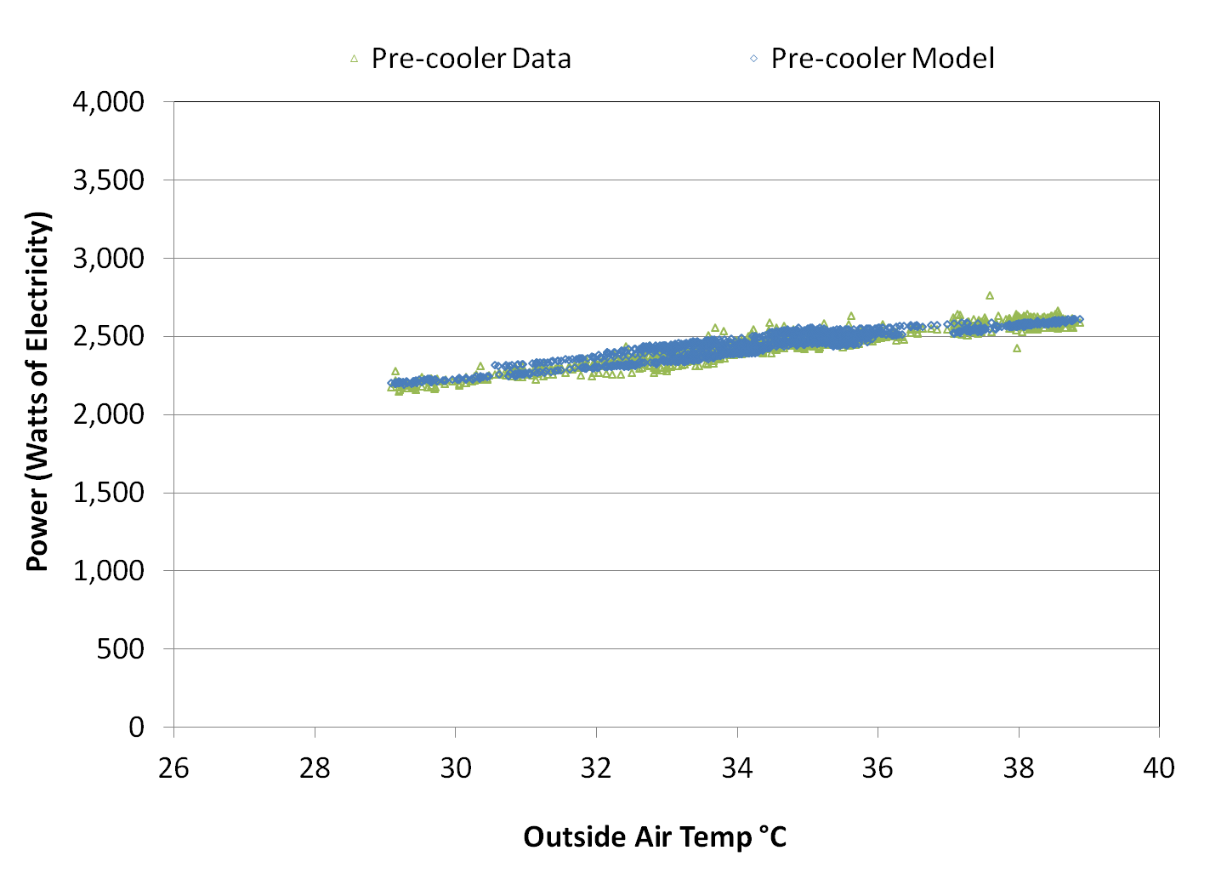

Figure 6 - Measured condensing unit power with pre-cooler compared to predictions based upon constant evaporative effectiveness of 0.51 in Equation 5.

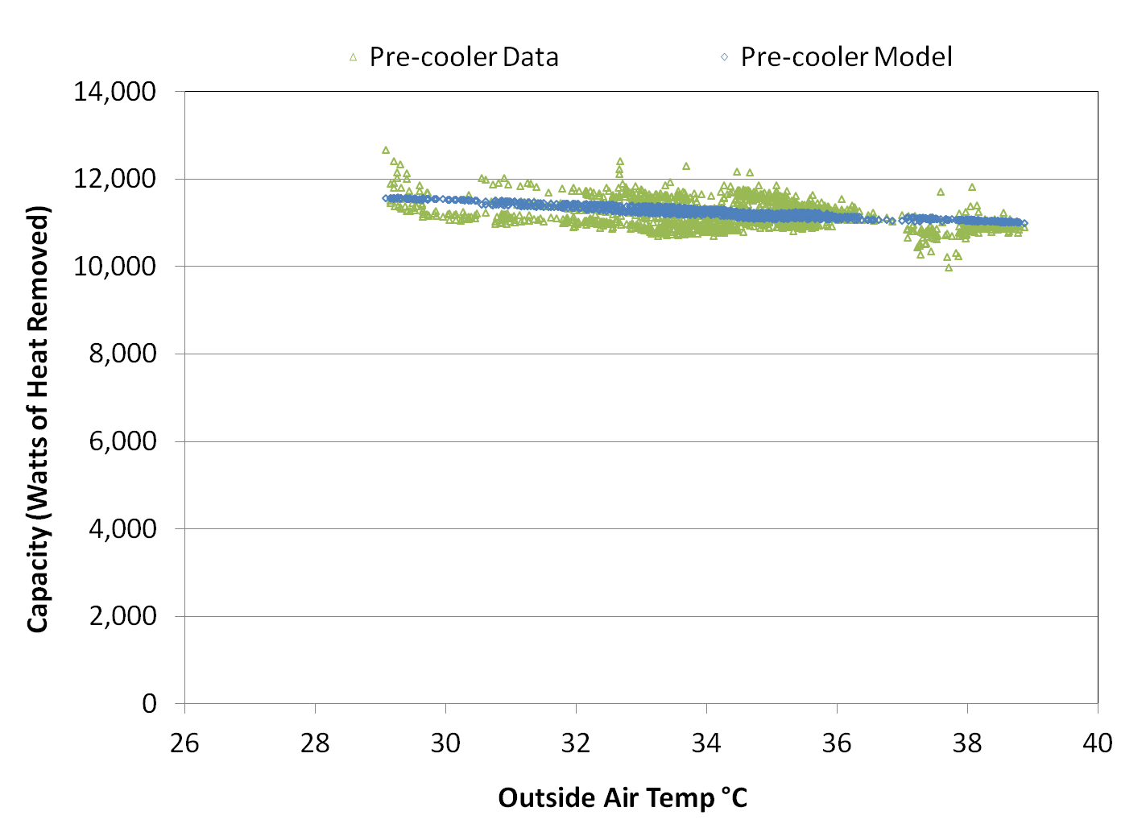

Figure 7 – Measured system capacity with pre-cooler compared to predictions based upon constant evaporative effectiveness of 0.51 in Equation 5.

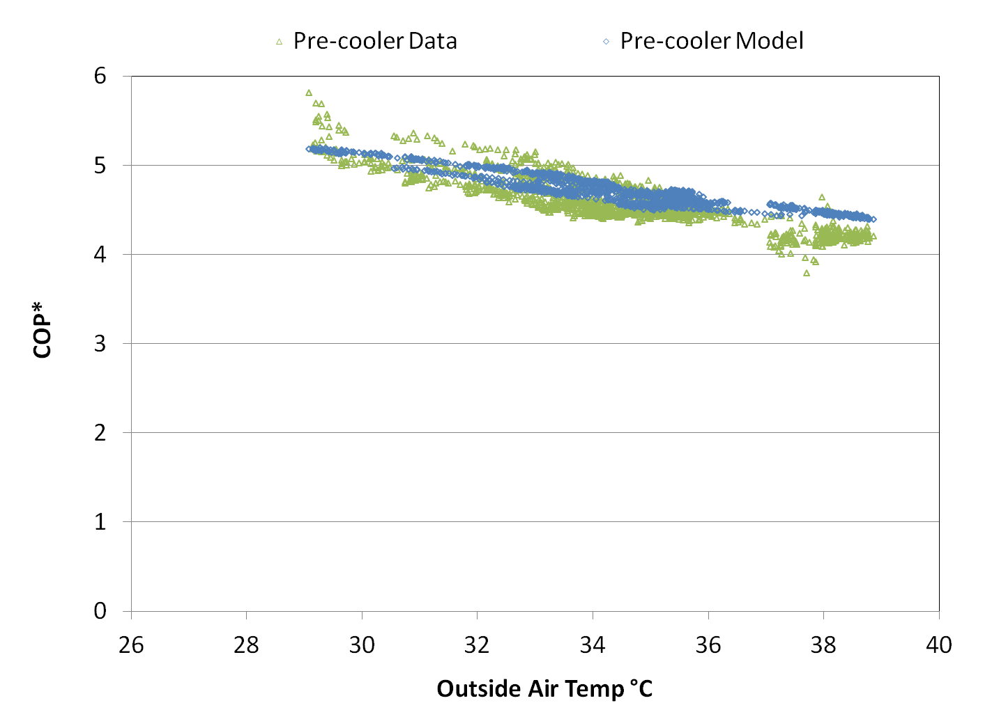

Figure 8 – Measured system COP* with pre-cooler compared to predictions based upon constant evaporative effectiveness of 0.51 in Equation 5. Power for evaporator fan not included.

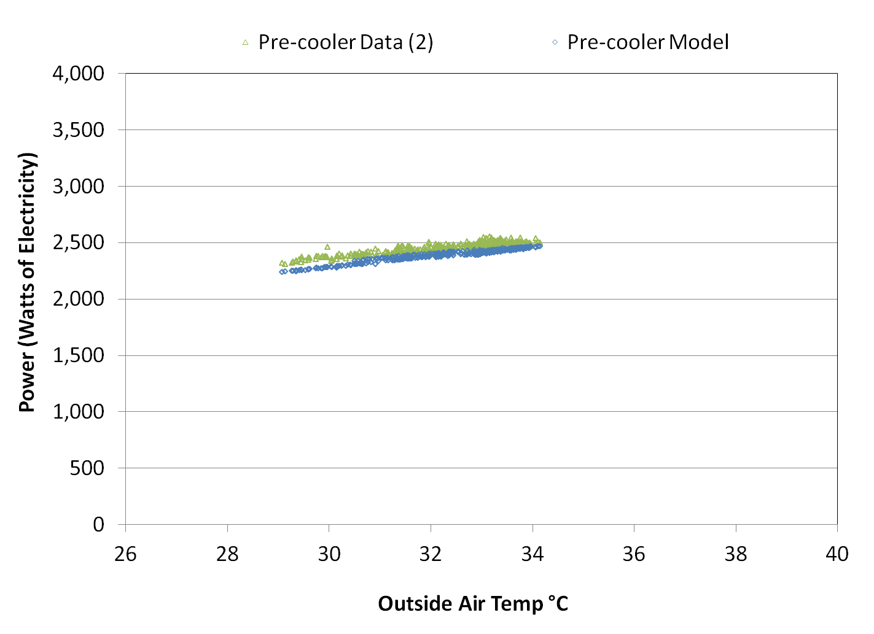

Figure 9 – Measured condensing unit power with pre-cooler compared to predictions based upon constant evaporative effectiveness of 0.51 in Equation 5, for second data set that was not used to calculate evaporative effectiveness..

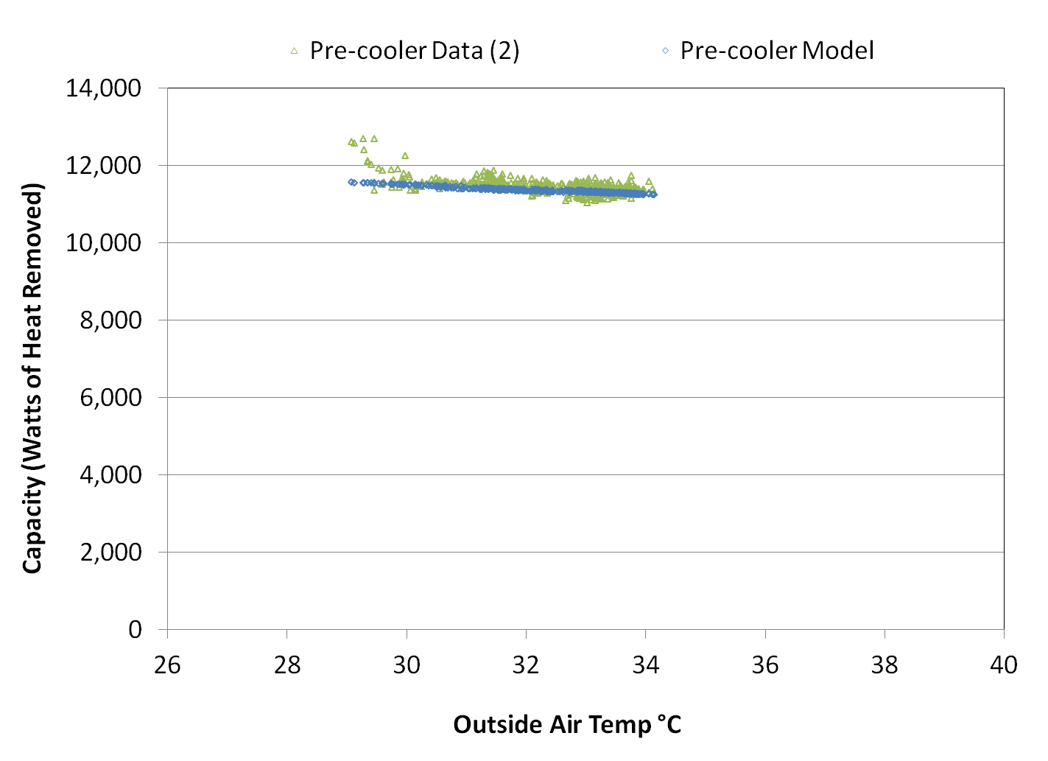

Figure 10 - Measured system capacity with pre-cooler compared to predictions based upon constant evaporative effectiveness of 0.51 in Equation 5, for second data set that was not used to calculate evaporative effectiveness.

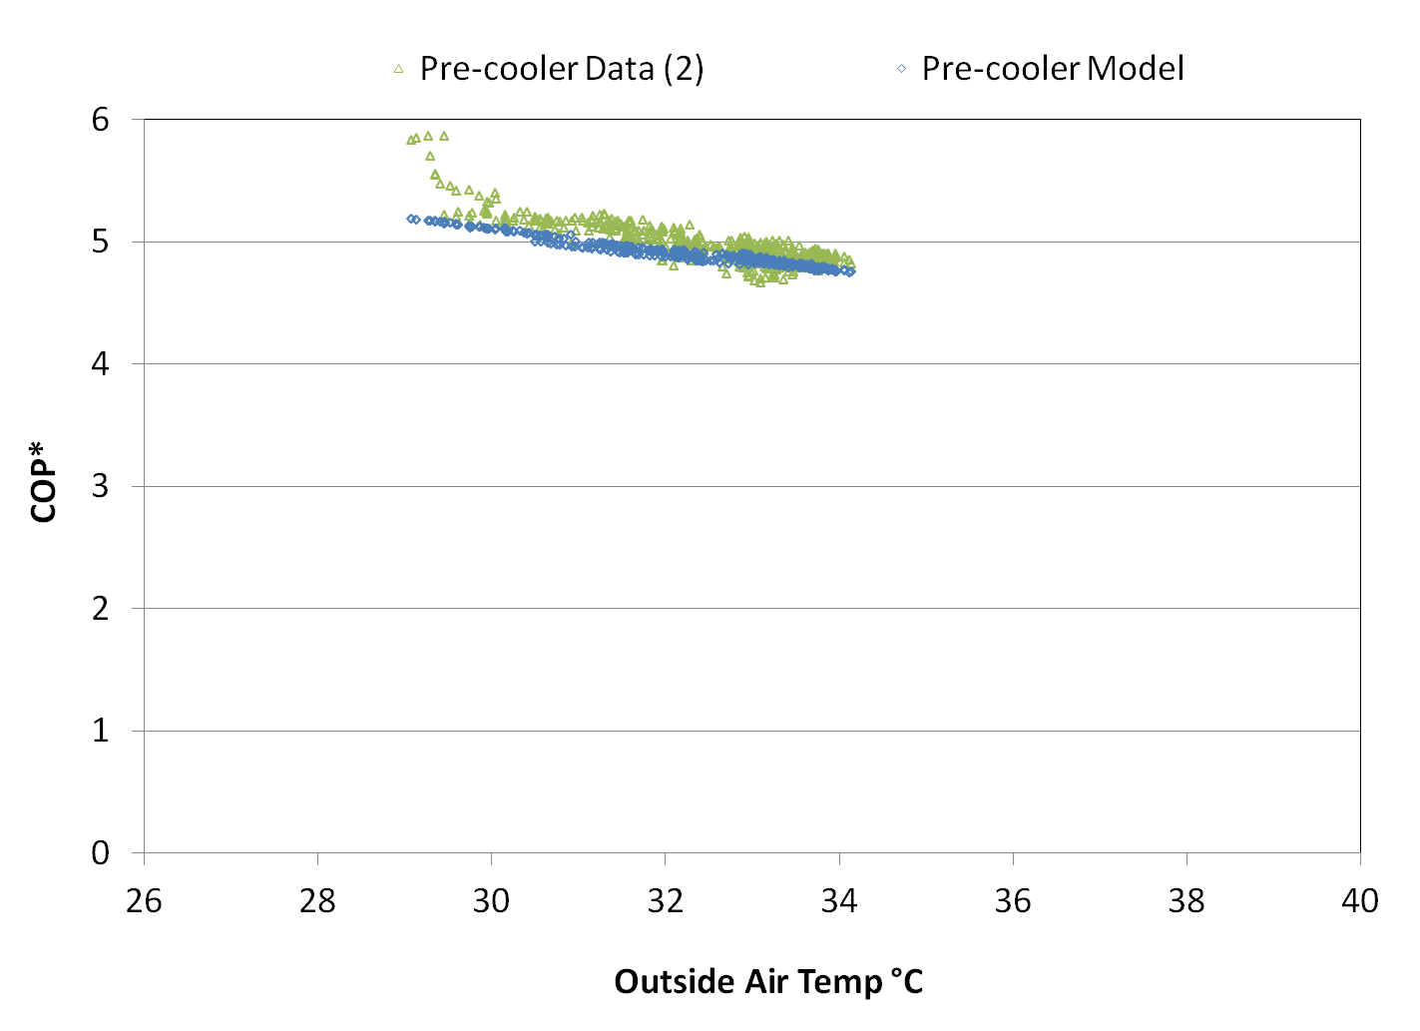

Figure 11 – Measured system COP* with pre-cooler compared to predictions based upon constant evaporative effectiveness of 0.51 in Equation 5, for second data set that was not used to calculate evaporative effectiveness. Power for the evaporator fan not included.

## Wind Effects

The effects of wind were not considered in the previous analysis, however wind during the experiment varied between 0-5 m/s with an average speed of 2.2 m/s. Wind is expected to have some impact on evaporative effectiveness because it can reduce the amount of water reaching the evaporative media. For the initial data set of 1500 points, evaporative effectiveness was calculated with Equation 6 using the system power data and plotted with respect to average wind speed over 1 minute interval (). While there does appear to be a correlation, it is difficult to discern, because there can be a time delay between changes in wind speed, and changes in performance, such that the performance change may happen minutes after the wind disruption. It is also clear that there is additional structure in the data, perhaps due to differences in wind direction.

Further analysis shows the results of averaging over 15 minute intervals (). This analysis also includes a filter to remove outliers in which the wind was extremely gusty over the 15 minute interval. Data was excluded if the standard deviation of the wind divided by the average wind exceeded 0.3, or if the standard deviation of the evaporative effectiveness divided by the average exceeded 0.1. Further study will be required to better understand the impact of wind on evaporative pre-coolers.

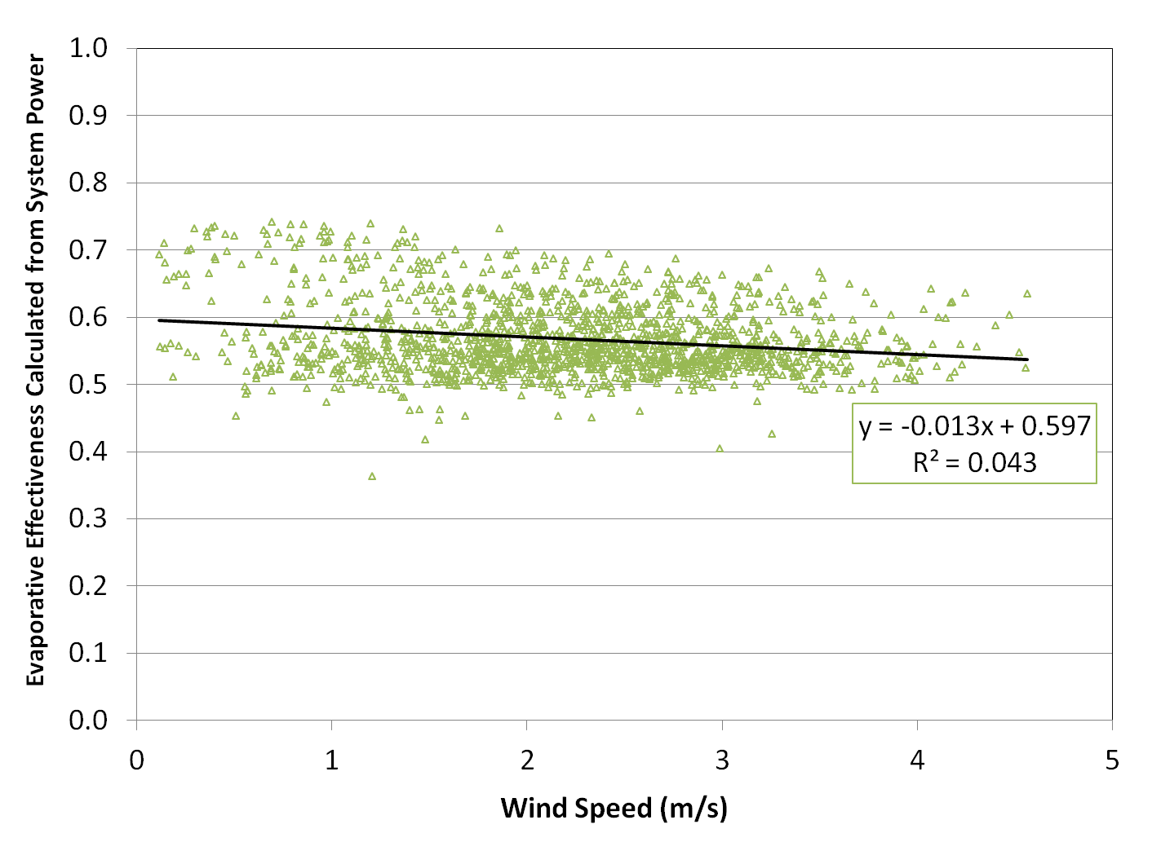

Figure 12 – Wind speed versus evaporative effectiveness by 1 minute average

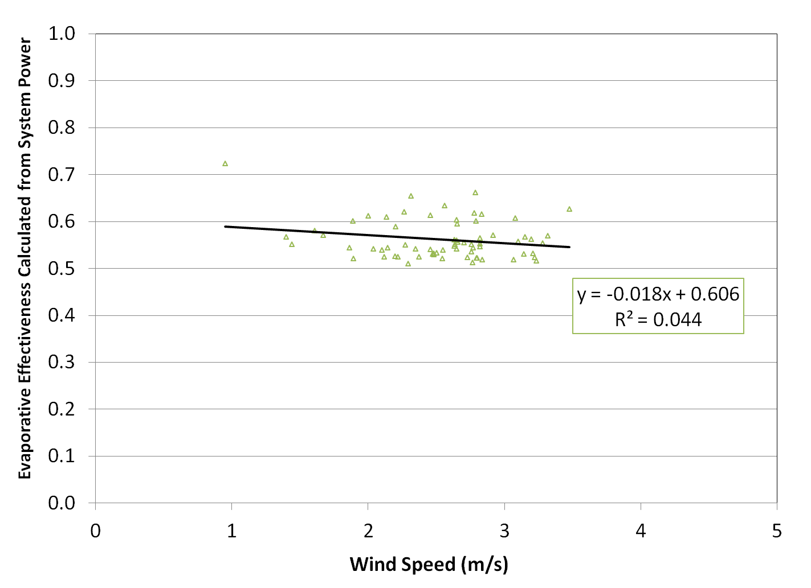

Figure 13 – Wind speed versus evaporative effectiveness by 15 minute average

## Condenser Coil Differential Pressure

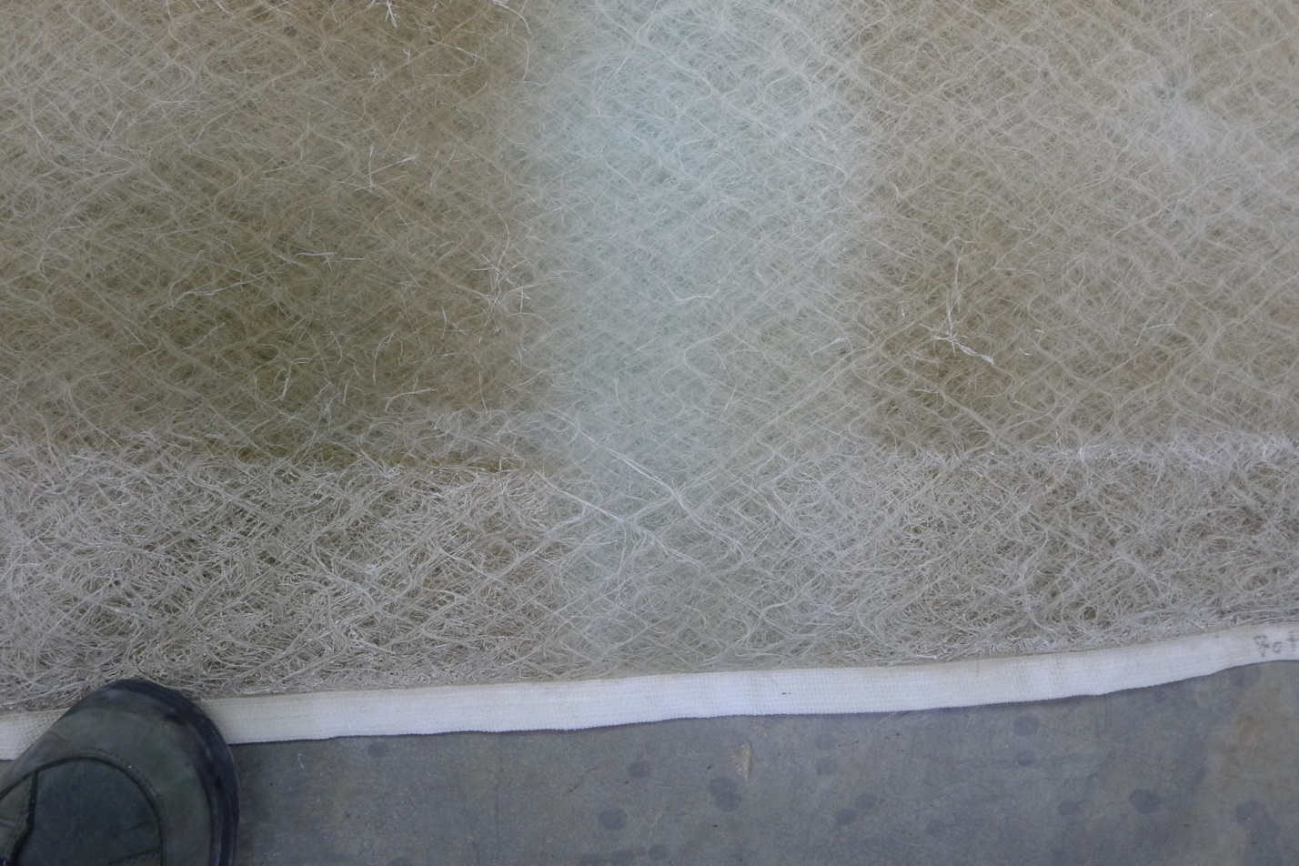Without the pre-cooler installed, the pressure differential between the inside of the condenser and outside was 14.5 Pa. Installing the pre-cooler increased the back pressure to 24 Pa with the water on, which slowly increased over 1500 minutes of runtime to 26 Pa (Figure 15). Some scale from hard water in Davis (averaging 400 PPM) was visible on the fiber glass blanket at the end of the experiment and the fiber glass blanket was breaking down. The pre-cooler was operated for approximately 10 days, although the blanket was left installed and exposed to the sun for four months. When the blanket was removed, some scale and dirt was visible and the fiber glass had become more brittle and flaky (). The manufacturer recommends replacing the blanket one to two times a year. The condensing unit itself was well protected from hard water by the blanket.

Figure - Fiber glass blanket at end of experiment

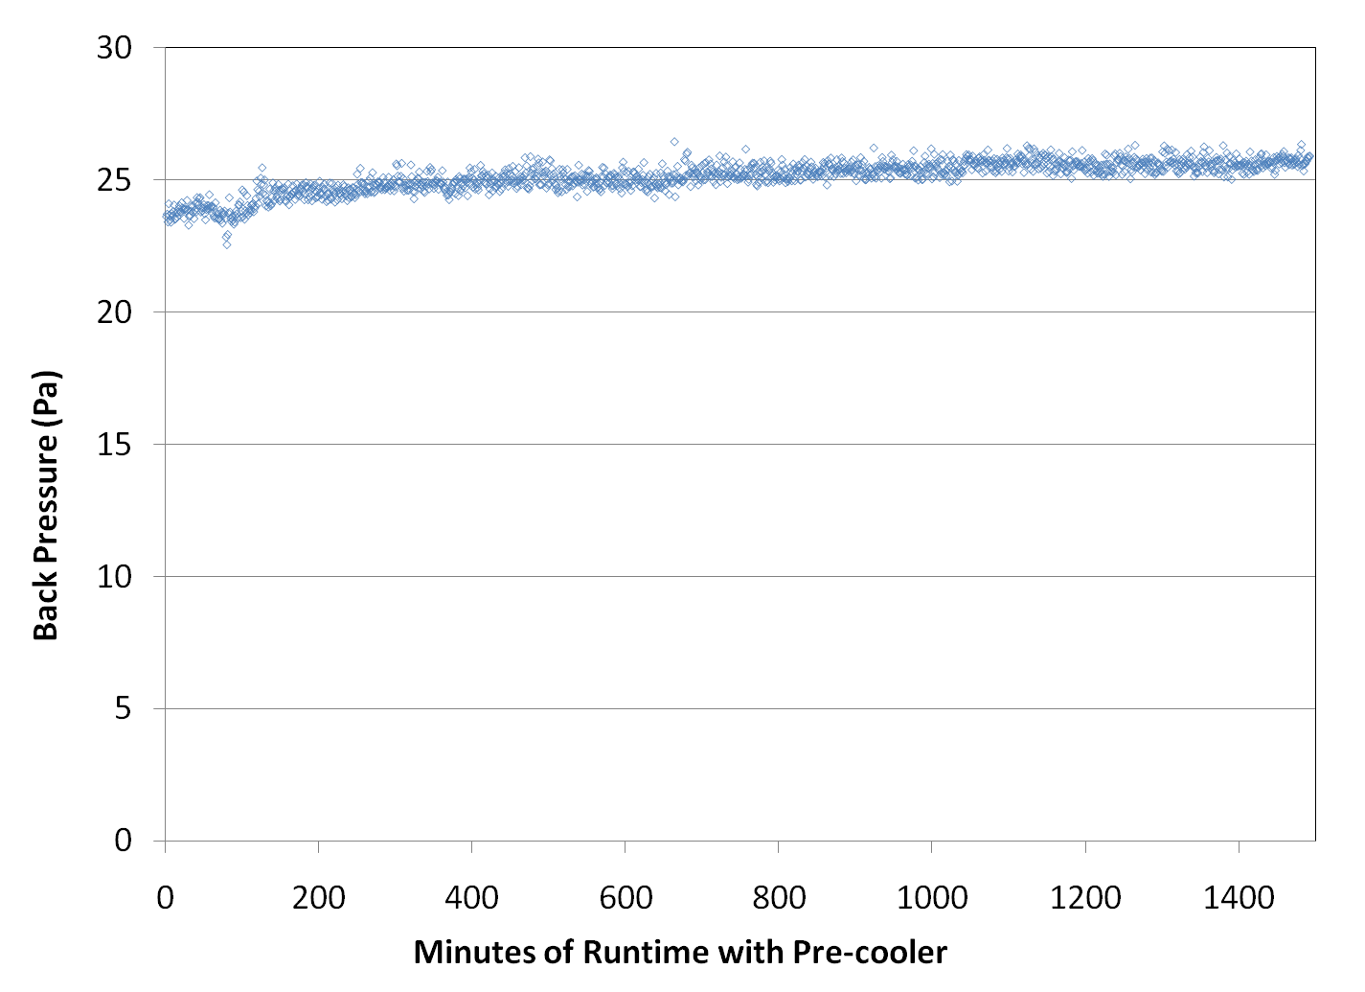

Figure 15 - The pressure differential between the inside and outside of the condensing unit with pre-cooler installed.

## Water-Use

The water-use of the pre-cooler averaged 0.51 liters per minute with a standard deviation of 0.02 liters per minute. The pre-cooler design includes one on/off solenoid valve so water use does not vary with weather conditions. Water also does not re-circulate, so if the water is not evaporated on the pad it is lost to the environment (by wind, run-off, etc).

In order to calculate the percentage of water used by the pre-cooler, measurement of the airflow through the condensing unit is required. Using a blower door to estimate the air flow as described in the methods section, the air flow was calculated to be 3370 CFM (1590 l/s)with the pre-cooler installed and 3500 CFM (1652 l/s) without, which is a 4% difference. The manufacturer’s specification for the unit is 4000 CFM (1888 l/s). Note that this high efficiency condensing unit has significantly higher airflow than a standard 3-ton unit.

For the same 1500 point data set used to analyze condensing unit performance, the water-use effectiveness was calculated using the condensing unit air flow measurement, the water supply measurement, outdoor air conditions, and the evaporative effectiveness of the pre-cooler calculated from the condensing unit power data. The average water use effectiveness (defined as the fraction of the supplied water that is evaporated) was calculated to be 66%, and the value was strongly correlated to outdoor air temperature and wet bulb depression ( and ). The correlation with wind was weak (Figure 18), although it does appear to be in the right direction.

The strong correlation with outdoor air temperature and wet bulb depression shows that the pre-cooler can efficiently use the fixed rate of water when there is a large capacity for the air to evaporate the water (when the wet bulb depression is large). At other times, the amount of water sprayed significantly exceeds the evaporation rate. Reducing the water flow rate would reduce wasted water. However, this would also reduce the product’s ability to save electricity during peak load. For a fixed flow rate device, the flow rate appears to be reasonable as minimal water is wasted during peak times.

## 

Figure 16 - Percent of water use for pre-cooling versus the outdoor air dry bulb temperature

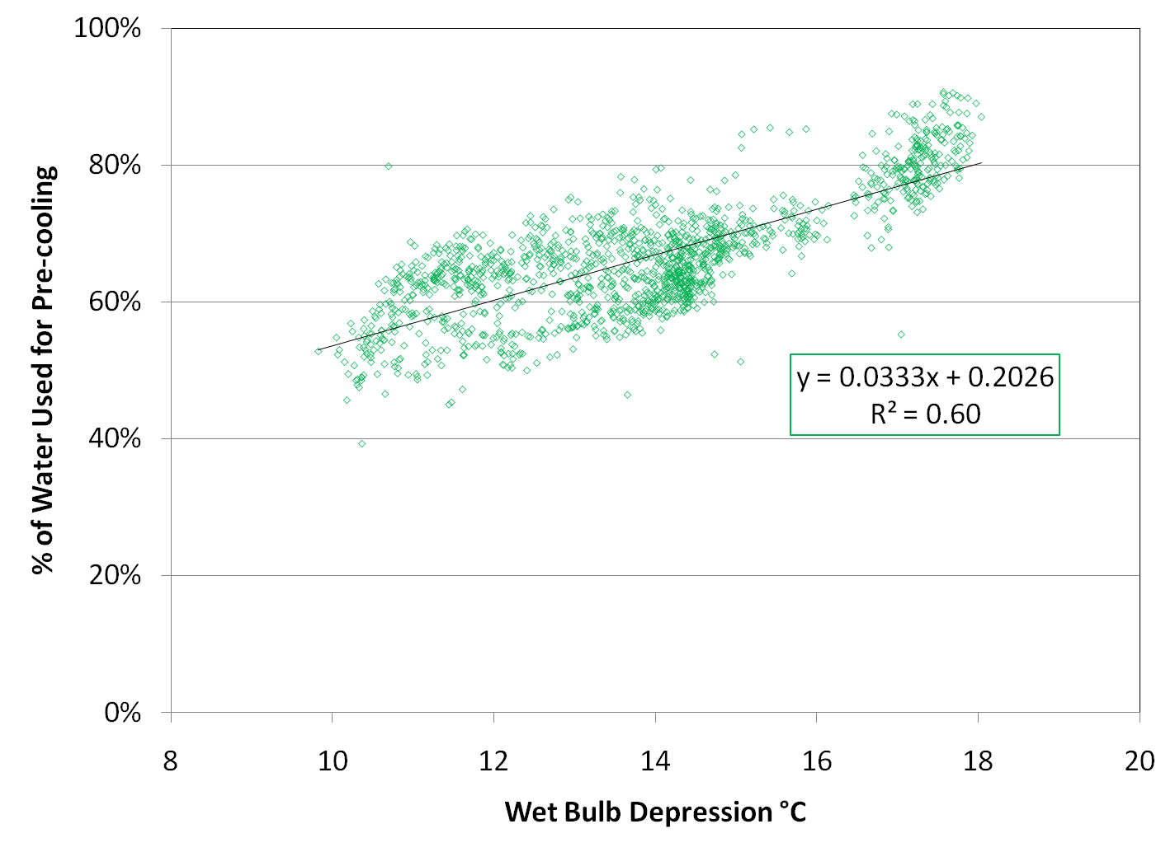

Figure 17 - Percent of water use for pre-cooling versus outdoor air wet bulb depression

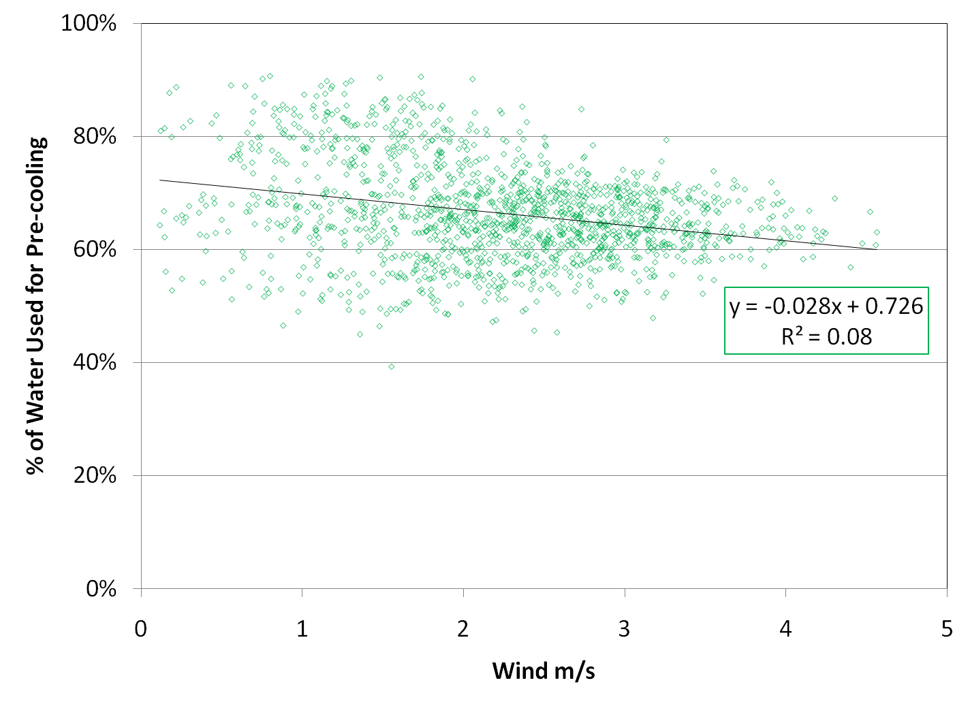

Figure 18 - Percent of water used for pre-cooling versus wind speed

## Economics

An analysis was completed to estimate the simple payback of the AC Spritzer in several California climate zones. The following assumptions were applied:

1. Average California residential electricity price of $0.136 per kWh[2].
2. Average California residential water rate of $0.86 per cubic meter[3].
3. Initial cost of the AC Spritzer of $375.
4. Annual maintenance cost of $24 (replacing the fiberglass blanket once per season).

The loads typical for a 15 year old house with a 3-ton condensing unit were generated using Micropas ® in climate zones 2, 9, 10, 11, 12, and 13. The analysis was completed for a baseline condensing unit and then for the pre-cooler retrofit assuming three different control strategies: the pre-cooler operates only when the outdoor air temperature exceeds 32.2°C (90°F) and the condensing unit is on, the pre-cooler operates only when the outdoor air temperature exceeds 26.6°C(80°F) and the condensing unit is on, and the pre-cooler operates when the condensing unit is on (regardless of outdoor air temperature).

For all calculations, the baseline system and pre-cooler system with water off were modeled as shown in and . The pre-cooler system with water on was modeled as described by Equation (EE=0.51). For each hour, the fractional run time of the air conditioner was determined by dividing the cooling load required by the capacity of the condensing unit at the outdoor air temperature. The cooling capacity required for an hour never exceeded the capacity of the condensing unit. The power, electricity, and water required for the hour were then calculated. The savings per year were calculated using the average cost of electricity and water. The simple payback was then calculated taking into account the initial cost and yearly maintenance costs.

The results show the simple payback to vary within a large range, paying back in as quickly as two years in climate zone 15 to possibly never in climate zone 2 (). Operating the pre-cooler when the temperature is at least 26.6°C or operating it whenever the condensing unit is on improves the yearly savings. Operating in cooler temperatures will result in lower water use efficiency but will still improve absolute cost savings because the increase in water cost is less than the electricity cost savings. The manufacturer recommends programming the threshold at 32.2°C but allows for it to be adjusted lower.

The simple payback analysis not does include any potential incentive payment from the utility. If the utility values the cost of reducing peak demand at $650/KW (the approximate cost of a new peaking power plant), and provides an incentive at that level, saving 0.8 KW per pre-cooler would translate to an incentive of $520, which is only slightly less than the cost of the particular pre-cooler tested. This would make the payback periods be almost immediate. However, valuing the peak demand reduction for a pre-cooler at $650/KW is probably not appropriate, considering the likely longevity of the product, and the potential for some of the peak savings being taken back in the form of improved comfort (i.e. the portion associated with capacity improvement, in applications with undersized cooling equipment).

Table 6 - Results of simple payback analyses for the AC Spritzer by climate zone and operating configuration. 1Peak is defined as the hour in the climate zone analyzed with the largest cooling load. 2Savings ($/Yr) equals electricity cost savings minus water cost.

|  |  |  |  |  |  |  |  |
| --- | --- | --- | --- | --- | --- | --- | --- |
| Pre-cooler operates above 32.2°C (90°F) | | | | | | | |
| Climate Zone | Baseline (kWh) | Retrofit (kWh) | Savings (kWh/Yr) | Peak1  Savings (kW) | Water used (m3/yr) | Savings2  ($/Yr) | Payback (years) |
| 2 | 756.5 | 655.0 | 101.5 | 0.83 | 3.6 | $11.04 | - |
| 9 | 1410.5 | 1268.8 | 141.6 | 0.89 | 5.5 | $14.97 | - |
| 10 | 1806.8 | 1493.1 | 313.7 | 0.98 | 10.7 | $34.41 | 34 |
| 12 | 1563.0 | 1354.0 | 208.9 | 0.87 | 7.4 | $22.66 | - |
| 13 | 2995.0 | 2426.1 | 568.9 | 0.90 | 18.6 | $63.14 | 9 |
| 15 | 5540.6 | 4064.6 | 1476.0 | 1.14 | 42.4 | $168.81 | 2 |
| Pre-cooler operates above 26.6°C (80°F) | | | | | | | |
| Climate Zone | Baseline (kWh) | Retrofit (kWh) | Savings (kWh/Yr) | Peak1 Savings (kW) | Water used (m3/yr) | Savings2 ($/Yr) | Payback (years) |
| 2 | 756.5 | 551.1 | 205.4 | 0.83 | 7.9 | $21.81 | - |
| 9 | 1410.5 | 1063.4 | 347.0 | 0.89 | 14.9 | $35.49 | 30 |
| 10 | 1806.8 | 1266.3 | 540.5 | 0.98 | 20.3 | $57.71 | 10 |
| 12 | 1563.0 | 1138.3 | 424.6 | 0.87 | 16.9 | $44.55 | 17 |
| 13 | 2995.0 | 2118.4 | 876.6 | 0.90 | 32.5 | $94.00 | 5 |
| 15 | 5540.6 | 3673.2 | 1867.3 | 1.14 | 58.0 | $209.88 | 2 |
| Pre-cooler operates when condensing unit is on | | | | | | | |
| Climate Zone | Baseline (kWh) | Retrofit (kWh) | Savings (kWh/Yr) | Peak1 Savings (kW) | Water used (m3/yr) | Savings2($/Yr) | Payback (years) |
| 2 | 756.5 | 521.9 | 234.6 | 0.83 | 9.7 | $24.30 | - |
| 9 | 1410.5 | 1013.0 | 397.5 | 0.89 | 18.4 | $39.52 | 23 |
| 10 | 1806.8 | 1235.5 | 571.2 | 0.98 | 22.3 | $60.28 | 10 |
| 12 | 1563.0 | 1093.3 | 469.7 | 0.87 | 19.8 | $48.33 | 14 |
| 13 | 2995.0 | 2048.9 | 946.1 | 0.90 | 36.7 | $100.10 | 5 |
| 15 | 5540.6 | 3588.5 | 1952.0 | 1.14 | 62.7 | $217.65 | 2 |

## Installation and Operation

The installation was straightforward and took one hour to complete by two people. The tools required were gloves and a drill to mount the control unit. The temperature sensor was difficult to place because the manual recommends that it be in the shade away from the mist to avoid incorrect temperatures from direct sun. This was difficult on a rooftop but may be easier at a residential home. The electronics are simple, but the included display was difficult to understand at times.

Once installed, the unit operated without incident for the entire month of July. After the experiment concluded, WCEC continued to operate the pre-cooler. Later in the summer it was observed that some of the misters clogged. There were easily fixed by scratching off the mineral deposits, but this a concern for long term operation in hard water areas. After removing the pre-cooler, there were a few areas on the case of the condensing unit that had mineral deposits, but the condenser coil itself was unharmed. This reinforces that it is important to get the top and bottom of the fiberglass blanket strapped down tight to protect the condenser coils.

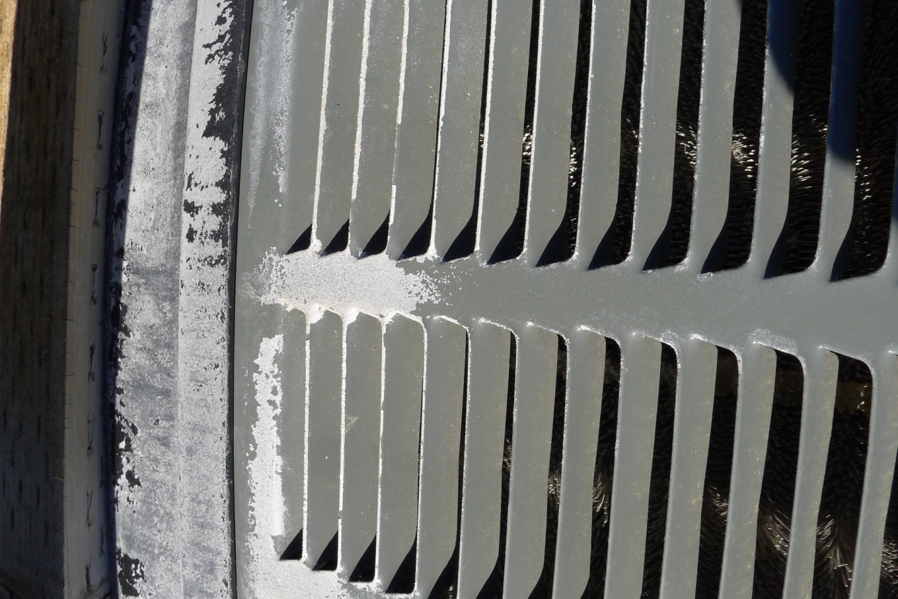

Figure 19 - Scale on the bottom of the condensing unit cover

## Evaporative Pre-Cooler Test Protocol

One of the goals of this project was to develop a protocol for rating the performance of evaporative pre-coolers. The key outputs associated with applying the protocol should allow us to estimate the following for any given evaporative pre-cooler:

1. Annual (i.e. over the cooling season) electricity savings potential (preferably one that can differentiate how that performance varies with climate zone – potentially including impact of wind)
2. Annual water use associated with achieving the annual electricity savings (water use efficiency)
3. Peak electricity demand reduction (function of weather conditions during peak demand period)
4. Sensitivity of product longevity, savings and associated water use to water quality (i.e. hardness)

The testing performed during this project has provided data to help turn our testing process into a more generic protocol. As of now, our recommended testing protocol consists of the following:

Measured Parameters

Testing should be performed on R-410A/R-22 equipment, and manufacturer’s published performance data relative to outdoor-air temperature must be recorded, as must measured dry-apparatus sensitivity to outdoor inlet condition (based upon performance with the dry pre-cooling apparatus installed at105, 100, 95, 90, 85, 80 dry-bulb temperature [oF] (40.6, 37.8 ,35.0 ,32.2 ,29.4 ,26.7 °C))

1. Evaporative Effectiveness

* Measured based upon measured equipment response to changes in condenser-air inlet temperature under dry conditions with apparatus installed
* Measured at a minimum of 4 outdoor air inlet conditions covering hot/dry, hot/humid, warm/dry, and warm/humid (e.g. in terms of DB/WB: 105/73, 95/75, 90/64, 82/73 [oF]) (40.6/22.8 35.0/23.9 32.2/17.8 27.8/22.8 [°C])
* ) conditions
* Generally measured under still air conditions, but also measured at wind speed of 5 mph and 5 wind directions at DB/WB: 90/64 [oF] (32.2/17.8°C))

1. Power Draw Reduction

* Measured based upon performance comparison of power draw at the same outdoor air inlet conditions, with and without apparatus installed
* Measured at a minimum of 4 outdoor air inlet conditions covering hot/dry, hot/humid, warm/dry, and warm/humid (e.g. in terms of DB/WB: 105/73, 95/75, 90/64, 82/73 [oF]) (40.6/22.8 35.0/23.9 32.2/17.8 27.8/22.8 [°C])
* Generally measured under still air conditions, but also measured at a wind speed of 5 mph and 5 wind directions at DB/WB: 90/64 [oF] (32.2/17.8°C))

1. Capacity Increase

* Measured based upon performance comparison of cooling capacity at the same outdoor air inlet conditions, with and without apparatus installed
* Cooling capacity should be measured on the heat-removal side, using the temperature drop of a hot-water loop cooled in a refrigerant to water heat exchanger that replaces the usual indoor-air evaporator.
* Measured at a minimum of 4 outdoor air inlet conditions covering hot/dry, hot/humid, warm/dry, and warm/humid (e.g. in terms of DB/WB: 105/73, 95/75, 90/64, 82/73 [oF]) (40.6/22.8 35.0/23.9 32.2/17.8 27.8/22.8 [°C])
* conditions
* Generally measured under still air conditions, but also measured at a wind speed of 5 mph (2.2 m/s) and 5 wind directions at DB/WB: 90/64[oF] (32.2/17.8°C))

1. Water Consumption and Effective Water Evaporation Fraction

* Water consumption at each DB/WB condition measured directly
* Evaporation fraction determined from measured water consumption, evaporative effectiveness and measured condenser air flow
* Measured at a minimum of 4 outdoor air inlet conditions covering hot/dry, hot/humid, warm/dry, and warm/humid (e.g. in terms of DB/WB: 105/73, 95/75, 90/64, 82/73 [oF]) (40.6/22.8 35.0/23.9 32.2/17.8 27.8/22.8 [°C])
* conditions
* Generally measured under still air conditions, but also measured at a wind speed of 5 mph and 5 wind directions at DB/WB: 90/64[oF] (32.2/17.8°C))

1. Performance degradation due to water consumption

* Determined by visual inspection in this project
* Could be determined by running device with specified poor-quality water for a fixed number of cycles, and then measuring the impact on of that water consumption on parameters 1 through 4

Discussion

The detailed protocols associated with parameters 1-5 above will be spelled out in more detail and vetted with a group of industry experts, most likely through a standards development process. The ultimate goal is to produce a standard test procedure, perhaps through ASHRAE (American Society of Heating, Refrigerating and Air-conditioning Engineers) or ASTM (American Society of Testing and Materials). One of the challenges associated with the development of a standardized test procedure is to be able to accommodate manufacturers’ innovative strategies for improving performance or reducing water consumption. In the case of evaporative pre-coolers, a key issue will be the control algorithms for water supply, which will impact effectiveness as well as water consumption. We believe that the public consensus process for standards development will help address this issue. This follow-on work is currently being funded by Southern California Edison through their HTSDA program. That program is funding further development, testing and refinement of the protocol, particularly as applied to Roof-Top Units (RTUs), and is also helping to fund the construction of a test facility at the WCEC to perform such tests on smaller (i.e. <5-ton capacity) equipment.

A first draft of the detailed test protocol is presented in Appendix A. Note that there are some questions about the proposed protocol that can only be answered by exercising it several times. For example, it is not clear whether there should be a steady-state test (e.g. 30-60 minutes of steady compressor operation), or a “standard compressor cycle” test (which might be 6 minutes on, 24 minutes off for residential equipment). Exercising of the protocol will be performed in 2012.

**Appendix A: Evaporative Pre-Cooler Evaluation Protocol (DRAFT)**

**Evaporative Pre-Cooler Specifications**

Manufacturer-Reported

*Applicability:* Cooling-equipment capacity – tons

Cooling-equipment design – slab-coil, 2-sided, 3-sided, 4-sided

*Control:* Water operation: with compressor, time-delayed start, time-delayed stop, cycling during single compressor cycle

Water flow: constant during compressor operation, ambient-temperature modulated, wet-bulb-depression modulated

*Water Management:* Single-pass, Sump with bleed (timed, adjustable, conductivity controlled), Sump with purge (timed, adjustable, conductivity controlled)

Maximum water draw, piping for water disposal

*Expected Media Life:* Seasons, years

**Cooling Equipment Used for Testing (Manufacturer Data)**

Make/Model/Serial #:

Refrigerant: R-410A or R-22

Manufacturer Data: Tout[oF] Capacity [Btu/h] Compressor Power [W]

80

85

90

95

100

105

**Tests to be performed:**

1. **NO-COOLER** Equipment Capacity and Compressor Power Draw
2. **DRY-COOLER** Equipment Capacity and Compressor Power Draw
3. **WET-COOLER** Equipment Capacity, Compressor Power Draw and Water Use
4. **WET-COOLER** Wind Sensitivity
5. **WET-COOLER** Poor-Water Sensitivity

**Test Conditions and Measurements**

**Table 1 - Test Operating and Test Condition Tolerances for Tests 1-5, all units in degrees Fahrenheit**

|  |  |  |  |  |
| --- | --- | --- | --- | --- |
| **Temperature Measurement** | **Test Condition** | **Instrument Accuracy** | **Test Operating Tolerance[4]** | **Test Condition Tolerance[5]** |
| Condenser Inlet, Dry Bulb | Varies | ± 0.5 | ±2.0 | ±0.5 |
| Condenser Inlet, Wet Bulb | Varies | ± 0.5 | ±2.0 | ±0.5 |
| Evaporator (Air), Dry Bulb | 80 | ±0.5 | ±2.0 | ±0.5 |
| Evaporator (Air), Wet Bulb | 67 | ±0.5 | ±2.0 | ±0.5 |
| Evaporator Inlet (Water) | 90 | ±0.5 | ±2.0 | ±1.0 |

**Condenser Power Measurement:** True-power meter accurate within 3% of reading

**Condenser Fan Flow Measurement (with DRY Pre-Cooler Installed):** accuracy within 3% of reading

**Option 1:** Tracer gas system

**Option 2:** Calibrated fan at zero pressure differential

**Capacity Measurement:**

**Option 1:** refrigerant to water heat exchanger with controlled inlet temperature and water flow, using water flow and temperature differential across heat exchanger to measure capacity. Water flow at 0.75-1 gpm/ton. Flow meter accuracy ±2% of reading.

**Option 2:** standard evaporator with controlled inlet temperature, humidity and air flow, using either refrigerant enthalpies and flow to measure capacity or air enthalpies and flow to measure capacity as specified in AHRI 210/240.

**Test Profile:**

**Option 1:** 10 minutes of steady state operation followed by 30 minutes of data collection.

**Option 2:** Steady-cyclic operation, potentially using 6 minutes on / 24 minutes off cycle, using the data from the second full cycle (similar to Residential SEER procedure) (At one ambient condition only)

**Data Reporting**

**Test 1: Cooling Equipment without Pre-Cooler (NO-COOLER)**

**The test shall carry the superscript “BASE” for baseline.**

|  |  |  |  |
| --- | --- | --- | --- |
| Reported Data: | Tout[oF] | Capacity [W] | Compressor Power [W] |
| a | 105 | $${CAP}_{105}^{BASE}$$ | $$P_{105}^{BASE}$$ |
| b | 95 | $${CAP}_{95}^{BASE}$$ | $$P_{95}^{BASE}$$ |
| c | 90 | $${CAP}_{90}^{BASE}$$ | $$P_{90}^{BASE}$$ |
| d | 82 | $${CAP}_{82}^{BASE}$$ | $$P_{82}^{BASE}$$ |

**Test 2: Cooling Equipment with Dry Evaporative Pre-Cooler Installed (DRY-COOLER)**

**This test shall carry the superscript “DRY” for DRY COOLER.**

|  |  |  |  |  |  |
| --- | --- | --- | --- | --- | --- |
| Reported Data: | Tout [oF] | Capacity [W] | Compressor Power [W] | COP* [-] | COP Change**  [-/oF] |
| a | 105 |  |  |  | N/A |
| b | 95 | $${CAP}_{95}^{DRY}$$ | $$P_{95}^{DRY}$$ | $${COP}_{95}^{DRY}$$ |  |
| c | 90 | $${CAP}_{90}^{DRY}$$ | $$P_{90}^{DRY}$$ | $${COP}_{90}^{DRY}$$ |  |
| d | 82 | $${CAP}_{82}^{DRY}$$ | $$P_{82}^{DRY}$$ | $${COP}_{82}^{DRY}$$ |  |
| e | 75 | $${CAP}_{75}^{DRY}$$ | $$P_{75}^{DRY}$$ | $${COP}_{75}^{DRY}$$ |  |
| f | 73 | $${CAP}_{73}^{DRY}$$ | $$P_{73}^{DRY}$$ | $${COP}_{73}^{DRY}$$ |  |
| g | 64 | $${CAP}_{64}^{DRY}$$ | $$P_{64}^{DRY}$$ | $${COP}_{64}^{DRY}$$ |  |

*DerivedQuantity ${COP}^{Dry}={{CAP}^{DRY}}/{P^{DRY}}$ at corresponding temperatures

**DerivedQuantity = (Column 5n –Column 5n-1)/(Column 2n-1 –Column 2n)

**Test 3: Cooling Equipment with Wet Evaporative Pre-Cooler Installed (WET-COOLER)**

**This test shall carry the superscript “WET” for WET COOLER.**

|  |  |  |  |  |
| --- | --- | --- | --- | --- |
| Reported Data: | Tout/TWB  [oF/ oF] | Capacity [W] | Compressor Power [W] | Water Use[kg/hr] |
| a | 105/73 | $${CAP}_{{105}/{73}}^{WET}$$ | $$P_{{105}/{73}}^{WET}$$ | $${\dot{m}}_{{105}/{73}}^{HOH}$$ |
| b | 95/75 | $${CAP}_{{95}/{75}}^{WET}$$ | $$P_{{95}/{75}}^{WET}$$ | $${\dot{m}}_{{95}/{75}}^{HOH}$$ |
| c | 90/64 | $${CAP}_{{90}/{64}}^{WET}$$ | $$P_{{90}/{64}}^{WET}$$ | $${\dot{m}}_{{90}/{64}}^{HOH}$$ |
| d | 82/73 | $${CAP}_{{105}/{73}}^{WET}$$ | $$P_{{105}/{73}}^{WET}$$ | $${\dot{m}}_{{105}/{73}}^{HOH}$$ |

**Test 4: Cooling Equipment with Wet Evaporative Pre-Cooler Installed (WIND TEST)** (Tout/TWB[oF] = 90/64)

**This test shall carry the superscript “WIND” for wind testing**

|  |  |  |  |  |  |
| --- | --- | --- | --- | --- | --- |
| Reported Data: | Wind  [m/s] | Wind Dir [deg] | Capacity  [W] | Compressor Power [W] | Water Use  [kg/hr] |
| a | 2.5 | 0 | $${CAP}_{{90}/{64}}^{wind @0°}$$ | $$P_{{90}/{64}}^{wind @0°}$$ | $${\dot{m}}_{{90}/{64}}^{HOH wind @0°}$$ |
| b | 2.5 | 45 | $${CAP}_{{90}/{64}}^{wind @45°}$$ | $$P_{{90}/{64}}^{wind @45°}$$ | $${\dot{m}}_{{90}/{64}}^{ HOH wind@45°}$$ |
| c | 2.5 | 90 | $${CAP}_{{90}/{64}}^{wind @90°}$$ | $$P_{{90}/{64}}^{wind @90°}$$ | $${\dot{m}}_{{90}/{64}}^{HOH wind@90°}$$ |
| d | 2.5 | 135 | $${CAP}_{{90}/{64}}^{wind @135°}$$ | $$P_{{90}/{64}}^{wind @135°}$$ | $${\dot{m}}_{{90}/{64}}^{HOH wind@135°}$$ |
| e | 2.5 | 180 | $${CAP}_{{90}/{64}}^{wind @180°}$$ | $$P_{{90}/{64}}^{wind @180°}$$ | $${\dot{m}}_{{90}/{64}}^{HOH wind@180°}$$ |

**Test 5: Cooling Equipment with Wet Evaporative Pre-Cooler Installed (WATER-IMPACT TEST)** (Tout/TWB[oF] = 90/64)  
  
This shall be denoted by the SuperScript **“WORN”.**

|  |  |  |  |  |
| --- | --- | --- | --- | --- |
| Reported Data: | Cycles  [-] | Capacity  [W] | Compressor Power [W] | Water Use  [kg/hr] |
| a | Full Season* | $${CAP}_{{90}/{64}}^{WORN}$$ | $$P_{{90}/{64}}^{WORN}$$ | $${\dot{V}}_{{90}/{64}}^{HOH WORN}$$ |

*Full Season = 1000 Full-load hours

**Derived Data**

**Table 6: Power Draw Reduction, Capacity Improvement and COP Improvement (%) over no precooler \***

|  |  |  |  |  |
| --- | --- | --- | --- | --- |
| Reported Data: | Tout/TWB | Power [%Pinc ] | Capacity [%CAPinc] | COP [%COPinc] |
| a | 105/73 | $$\frac{{(P}_{{105}/{73}}^{WET}-P_{105}^{BASE}}{{CAP}_{105}^{BASE}}$$ | $$\frac{{CAP}_{{105}/{73}}^{WET}-{CAP}_{105}^{BASE}}{{CAP}_{105}^{BASE}}$$ | $$\frac{{COP}_{{105}/{73}}^{WET}-{COP}_{105}^{BASE}}{{COP}_{105}^{BASE}}$$ |
| b | 95/75 | $$\frac{P_{{95}/{75}}^{WET}-P_{95}^{BASE}}{{CAP}_{95}^{BASE}}$$ | $$\frac{{CAP}_{{95}/{75}}^{WET}-{CAP}_{95}^{BASE}}{{CAP}_{95}^{BASE}}$$ | $$\frac{{COP}_{{95}/{75}}^{WET}-{COP}_{95}^{BASE}}{{COP}_{95}^{BASE}}$$ |
| c | 90/64 | $$\frac{P_{{90}/{64}}^{WET}-P_{90}^{BASE}}{{CAP}_{90}^{BASE}}$$ | $$\frac{{CAP}_{{90}/{64}}^{WET}-{CAP}_{90}^{BASE}}{{CAP}_{90}^{BASE}}$$ | $$\frac{{COP}_{{90}/{64}}^{WET}-{COP}_{90}^{BASE}}{{COP}_{90}^{BASE}}$$ |
| d | 82/73 | $$\frac{P_{{82}/{73}}^{WET}-P_{82}^{BASE}}{{CAP}_{82}^{BASE}}$$ | $$\frac{{CAP}_{{82}/{73}}^{WET}-{CAP}_{82}^{BASE}}{{CAP}_{82}^{BASE}}$$ | $$\frac{{COP}_{{82}/{73}}^{WET}-{COP}_{82}^{BASE}}{{COP}_{82}^{BASE}}$$ |

* All calculations must be multiplied by 100 to get %

**Table 7: Evaporative Effectiveness**

|  |  |  |
| --- | --- | --- |
| Reported Data: | Tout/TWB | Evaporative Effectiveness |
| a | 105/73 | $$EE=\%{COP}_{{105}/{73}}^{inc}*\frac{{COP}_{73}^{dry}}{{COP}_{73}^{dry}-{COP}_{105}^{dry}}$$ |
| b | 95/75 | $$EE=\%{COP}_{{95}/{75}}^{inc}*\frac{{COP}_{75}^{dry}}{{COP}_{75}^{dry}-{COP}_{95}^{dry}}$$ |
| c | 90/64 | $$EE=\%{COP}_{{90}/{64}}^{inc}*\frac{{COP}_{64}^{dry}}{{COP}_{64}^{dry}-{COP}_{90}^{dry}}$$ |
| d | 82/73 | $$EE=\%{COP}_{{105}/{73}}^{inc}*\frac{{COP}_{73}^{dry}}{{COP}_{73}^{dry}-{COP}_{82}^{dry}}$$ |

**Table 8: Effective Water Evaporation Fraction**

|  |  |  |
| --- | --- | --- |
| Reported Data: | Tout/TWB | Effective Water Evaporation Fraction |
| a | 105/73 | $${\dot{m}}_{air}*[W_{out}-W_{in}]/{\dot{m}}_{{105}/{73}}^{HOH}$$ |
| b | 95/75 | $${\dot{m}}_{air}*[W_{out}-W_{in}]/{\dot{m}}_{95/75}^{HOH}$$ |
| c | 90/64 | $${\dot{m}}_{air}*[W_{out}-W_{in}]/{\dot{m}}_{90/64}^{HOH}$$ |
| d | 82/73 | $${\dot{m}}_{air}*[W_{out}-W_{in}]/{\dot{m}}_{82/73}^{HOH}$$ |

**Table 9: Performance Degradation due to Wind**

Capacity degradation due to wind [%] =

${(CAP}_{{90}/{64}}^{wind @0º}+{CAP}_{{90}/{64}}^{wind @45º}+{CAP}_{{90}/{64}}^{wind @90º}+{CAP}_{{90}/{64}}^{wind @135º}+{CAP}_{{90}/{64}}^{wind @180º}-5*{CAP}_{{90}/{64}}^{no wind})/(5*{CAP}_{{90}/{64}}^{no wind})$

Power increase due to wind [%/(m/s)] =

$${(P}_{{90}/{64}}^{wind @0º}+P_{{90}/{64}}^{wind @45º}+P_{{90}/{64}}^{wind @90º}+P_{{90}/{64}}^{wind @135º}+P_{{90}/{64}}^{wind @180º}-5*P_{{90}/{64}}^{no wind})/(5*P_{{90}/{64}}^{no wind})$$

**Table 10: Performance Degradation due to Water Consumption**

Capacity degradation due to water use [%/season] =

$$\frac{{(CAP}_{{90}/{64}}^{WORN}-CAP_{{90}/{64}}^{Wet})}{CAP_{{90}/{64}}^{Wet}}$$

Power increase due to water use [%/season]

$$\frac{{(P}_{{90}/{64}}^{WORN}-P_{{90}/{64}}^{Wet})}{P_{{90}/{64}}^{Wet}}$$

1. E. Winandy, C. Saavedra, and J. Lebrun, Experimental analysis and simplified modeling of a hermetic scroll refrigeration compressor, Applied Thermal Engineering, 2002, pg 107-120.
2. Statewide Average Customer Class Electricity Prices , http://energyalmanac.ca.gov/electricity/index.html
3. 2006 California Water Rate Survey, Black and Veatch, http://www.kqed.org/assets/pdf/news/2006_water.pdf
4. The difference between the maximum and minimum measurement over the test duration
5. The difference between the required test condition and the average value over the test duration